**Term Project**

**Amakumo Medical Clinic System**

INFO 3135 (S10)

Advanced Web App Development

Instructor: Stephen Chiong

Kwantlen Polytechnic University

November 28, 2023

Prepared by

Janak Kalar - 100355636

Uday Garg - 100403047

Sergio “Kyo” Siu - 100307509

Anmol Mazoo - 100361851

# Contents

**Contents 2**

**Introduction 3**

Background 3

**Features 4**

Login 4

Registration 5

Authorization / Verification 6

User Interface 7

CRUD 8

## 

## 

# **Introduction**

## ***Background***

Amakumo Medical Labs is a clinic and research facility specializing in the most advanced bio engineered prosthetics, though it also accepts general patients.

Owing to a need to better organize information, reduce strain on the in house AI system, as well as allowing patients easier access to their medical information away from the clinic, the owner and head of operations, Sei Amakumo has commissioned us to develop a functional database system that allows clinic personnel to create and modify patient records as well as delete them if requested by patients.

Clinic personnel will also be able to upload files to update information in the present records. Patients will also be able to log in to view their own medical data.

## 

# **Features**

## ***Login***

Here we have a login page that can be used by both doctors and patients to login to their accounts or register. Users provide their email and password, which are validated against the stored information in the MySQL database.

Upon entering details, the PHP script retrieves the user details and checks for a match. If successful, the user is redirected to the home page, otherwise, an error message is displayed appropriately.

Further, the page offers a registration feature for people who do not have an account yet, with separate registration systems for Doctors and Patients.

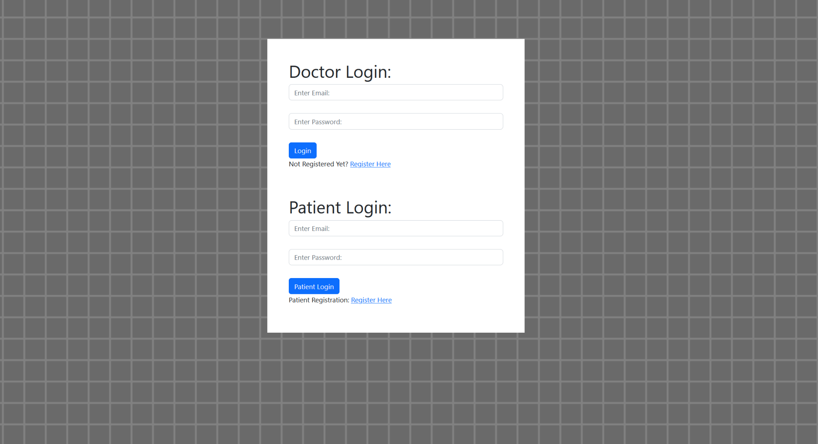

## 

## ***Registration***

Upon clicking on the “Register here”, the users are directed to the Registration page which allows them to create a new user account. We require them to put in their name, email and choose a password. In case of patients, we ask them for a health number as well. Upon getting the credentials, the system stores the email in the database and displays registration success message or an error message for incomplete data. Additionally, we give users an option to go back to the login page if they already are registered.



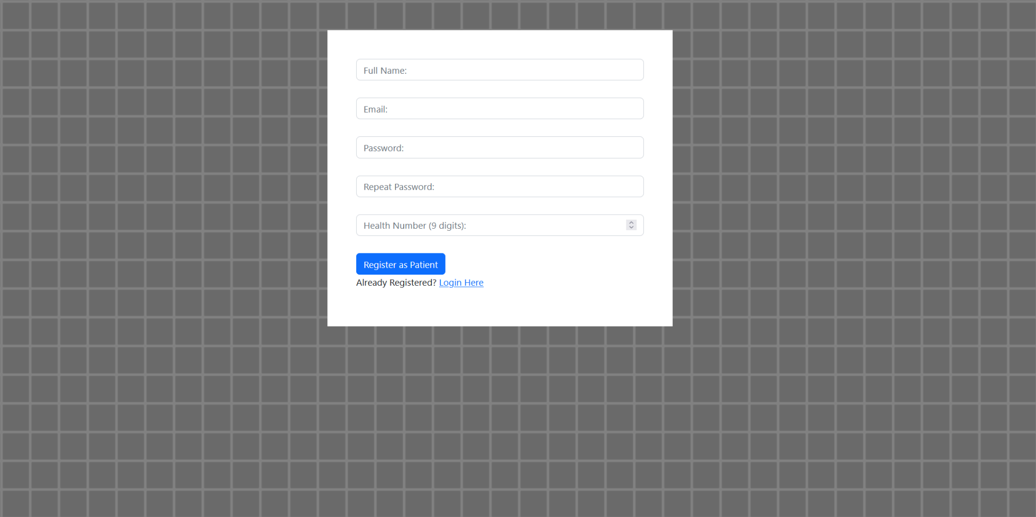

## ***Authorization / Verification***

The website ensures that the user has the correct permissions to be able to access any given system within the site.

Doctors are able to access the doctor home page, full CRUD access to the Medical Data as well as access to the file upload / viewing system.

Patients are able to access the patient home page, as well as view any medical data related to the accounts registered 9-digit health card number.

If the user tries to forcibly access other parts of the site with the URL bar, the application denies them entry, and also signs them out. You can only access pages that are valid to your permissions.

It is important to note that while providing a basic model for user authorization, this system has a potential to be built to another level by incorporating advanced features such as role-based access control, token-based authentication and it would be able to distinguish between different user roles or permissions. This can be implemented via future updates.

## ***User Interface***

All of our original graphical assets were made in house by Kyo using Paint.NET and Clip Studio Paint, then added to the site via a highly specialized CSS file, along with some elements borrowed from Bootstrap. Kyo’s experience with designing UIs for games allowed us to have a uniquely designed (albeit admittedly rushed) interface somewhat reminiscent of a point and click video game UI. (Many of the design elements borrowed inspiration from Fading Steel, a game Kyo and Anmol previously worked on.)

Our overall design philosophy was to make sure that it was simple, easy to use, but still professional looking enough to pass as a proper medical facility’s site. We decided to use an overall pale colour scheme to give off the professional look and feel we were aiming for, while keeping a constant navigation bar to the side to make sure that all users will have an easy means to navigate the pages. We felt like this would streamline the processes well enough to make sure that accessing the information would not be a struggle for any user. Overall, we ended up with a design that we felt like made information easy to read and easy to access, which we believe helps accessibility in the end.

Below is a screenshot of the website’s homepage prior to implementation into a php. Note that the UI has been designed to be responsive to window sizes, allowing us to accommodate as many screen sizes as possible.

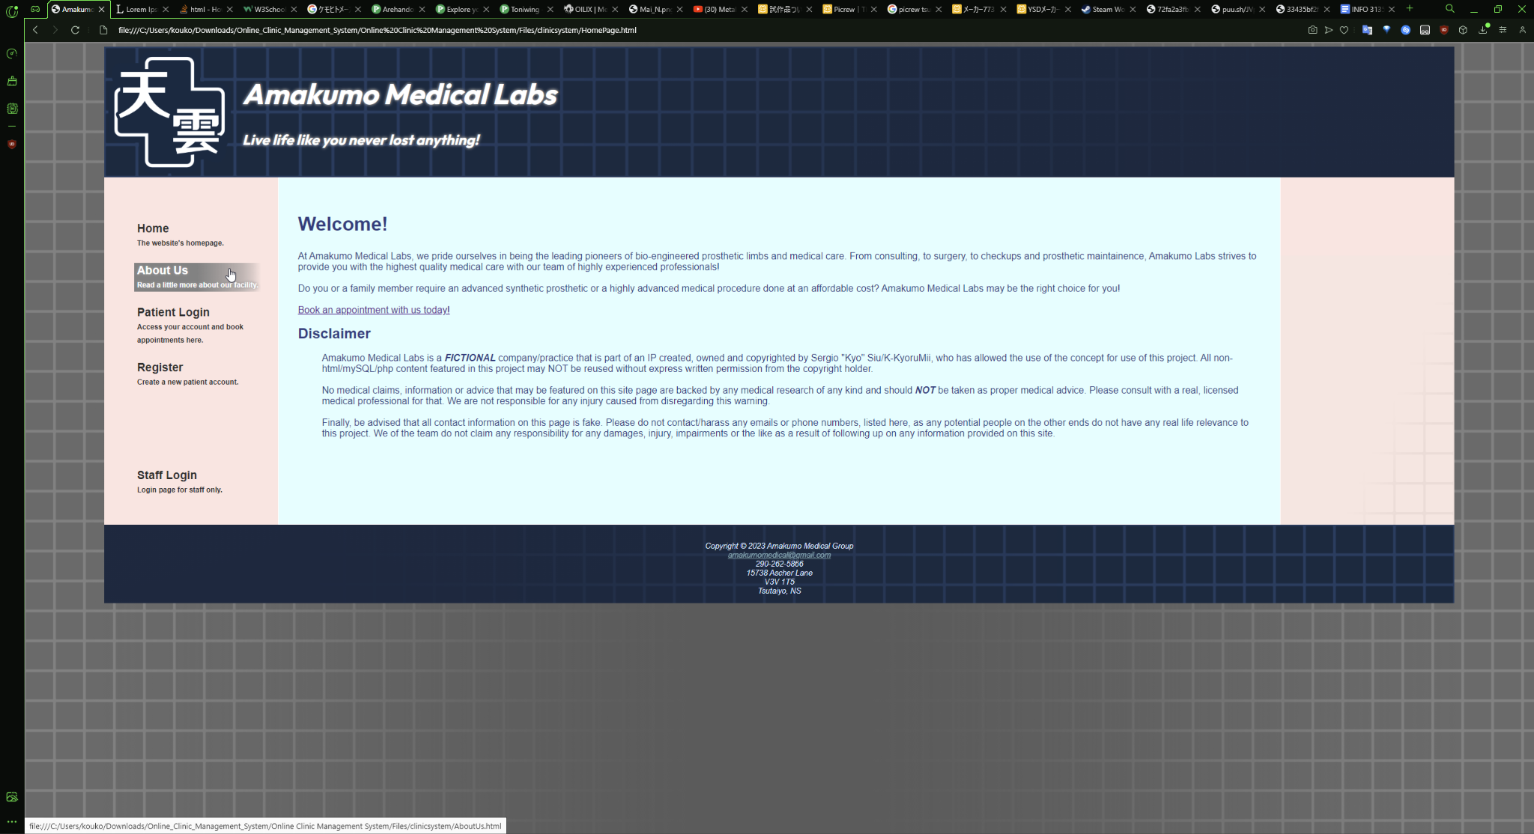

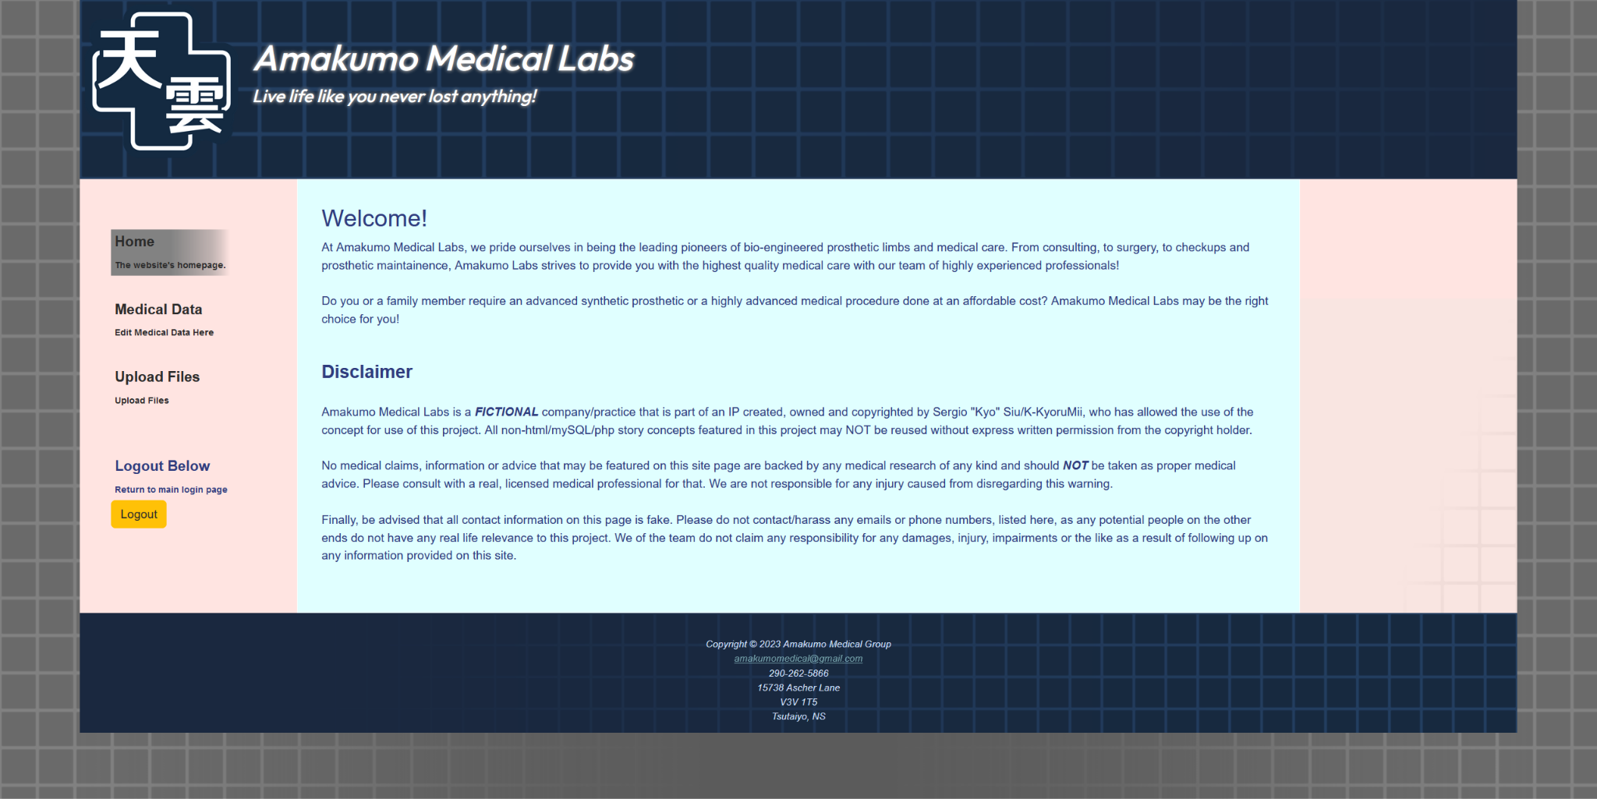

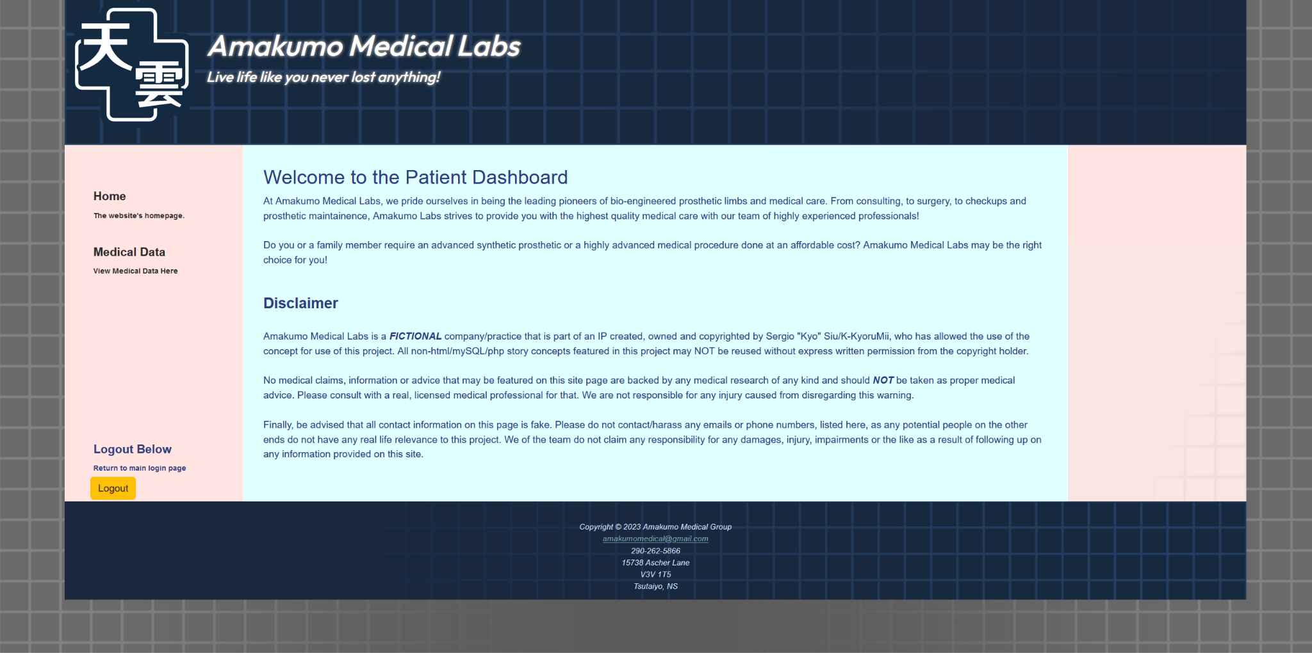

## ***CRUD***

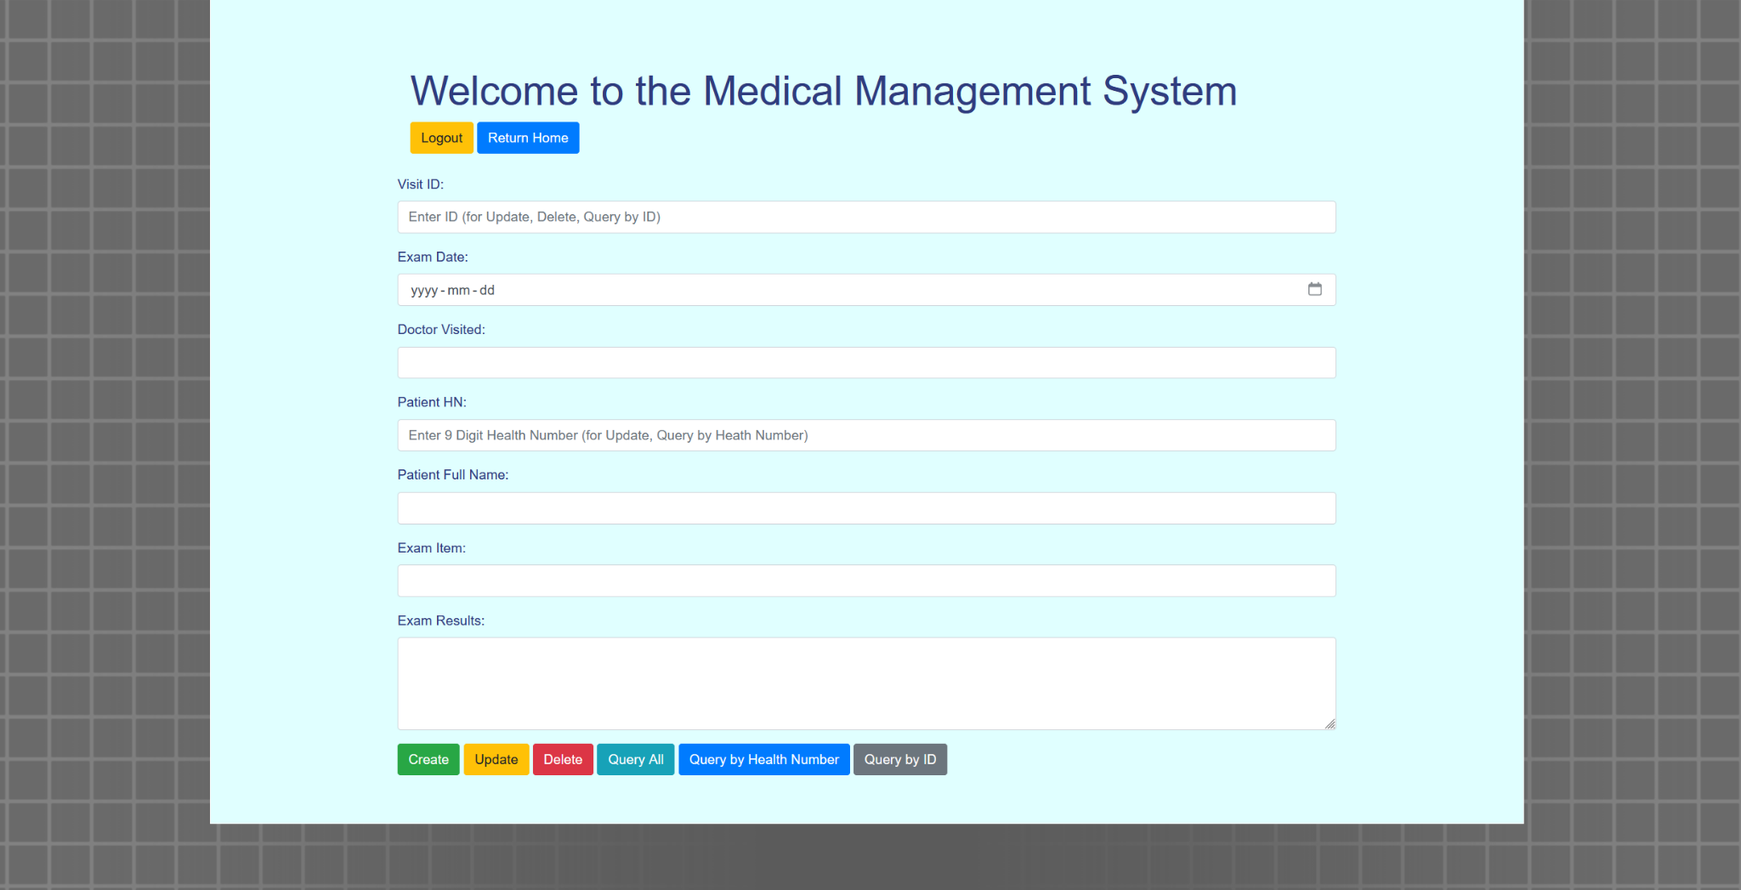

This site has a full medical management CRUD system. The end user is given a forum in which they fill the following data:

* VISIT ID = Only for updating, delete or querying purposes (Auto Generated upon create feature)
* EXAM DATE = The date of the examination
* DOCTOR VISITED = Name of the doctor of the examination
* PATIENT HN = Patients 9-digit health number (Also used in health number query feature)
* PATIENT FULL NAME = Full name of patient
* EXAM ITEM = Medical Procedure being done
* EXAM RESULTS = Details of what was tested

The user can fill in that data, in turn for the following functions

* CREATE = Create a new examination entry
* UPDATE = Update an existing examination (Based on ID)
* DELETE = Delete an existing examination (Based on ID)
* QUERY ALL = See all examinations
* QUERY BY HEALTH NUMBER = See all examinations pertaining to a specific health number
* QUERY BY ID = See examination based on ID

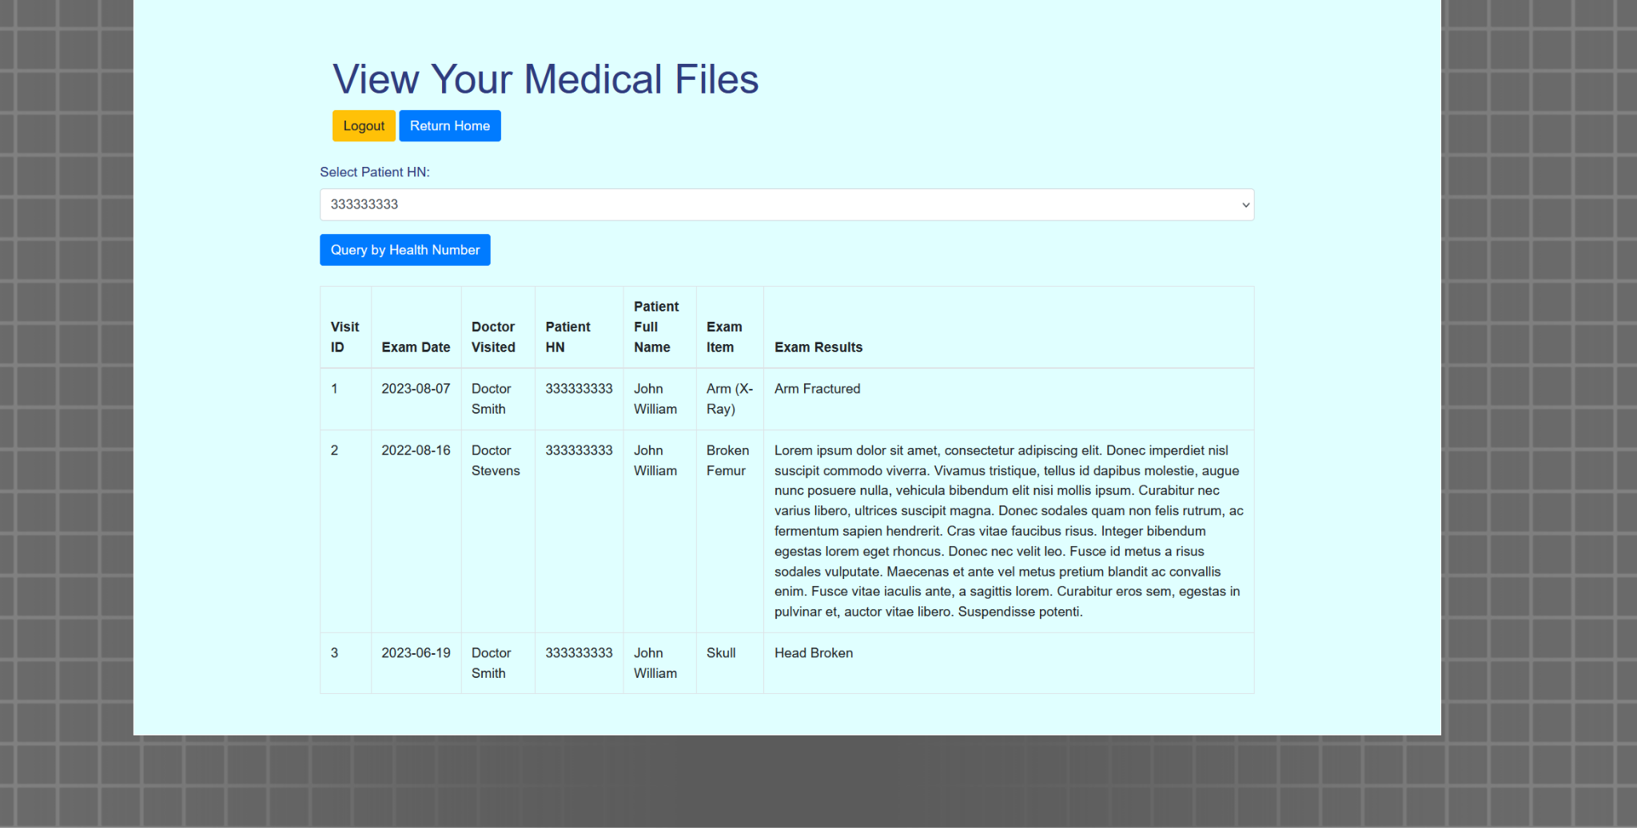

Similarly, for the patients, they have a page that only allows them to see medical files pertaining to their own health number (That was registered to their account upon account registration).

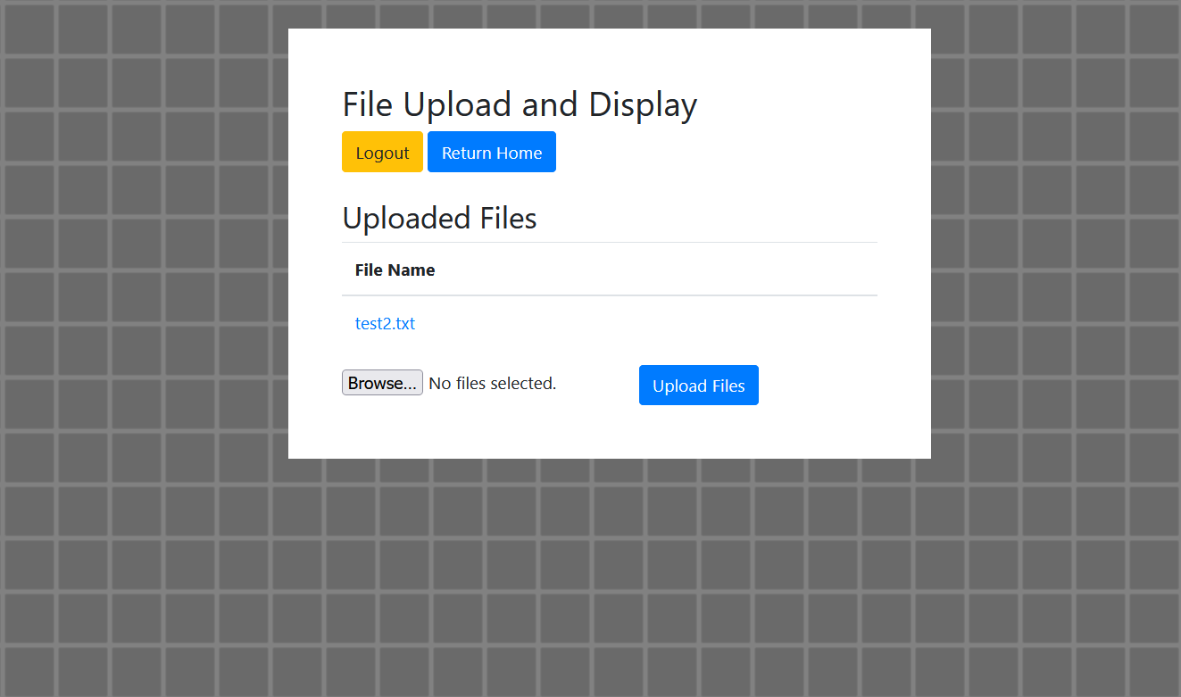

Doctors are also able access an upload system, where they are able to upload text documents and also preview the contents of the file.